**Experiment No. 20**

**Experiment Name: Write a program in Visual basic to prepare a list of items in one list box. After selecting the items, the selection must be listed in second list. The program must also provide options by which user will be able to add the items from 1st list or 2nd list as well as options to remove items from the list.**

Private Sub cmdadd_Click() lstitem1.AddItem txtname.Text txtname.Text = "" txtname.SetFocus

End Sub

Private Sub cmddel_Click() lstitem2.RemoveItem lstitem2.ListIndex End Sub

Private Sub cmdexit_Click() End

End Sub

Private Sub cmdsel_Click() Dim i As Integer

If lstitem1.ListIndex = ‐1 Then Exit Sub

End If

For i = lstitem1.ListCount ‐ 1 To 0 Step ‐1

If lstitem1.Selected(i) = True Then lstitem2.AddItem lstitem1.List(i) lstitem1.RemoveItem (i)

End If Next i End Sub

Output:

labels

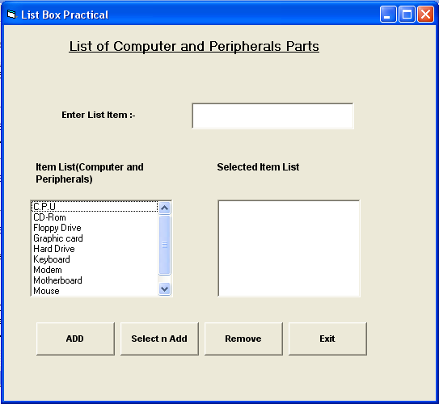

labels

textbox

labels

labels

List box

List box

**Experiment No. 21**

**Experiment Name: Write a program in Visual basic to find the sum of first 100 numbers entered using Do loop.**

Private Sub Form_Load() Dim a, sum As Integer sum = 0

a = 1 Do

sum = sum + a a = a + 1

Loop until a <= 100

MsgBox "The sum of first 100 no is sum " & sum & ".", vbInformation End Sub

**Output:**

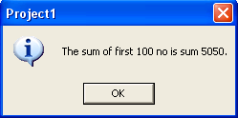

Command button

**Experiment No. 22**

**Experiment Name: Write a program in visual basic using Case condition that accepts the marks out of 100 of students in 4 subjects during execution. The program should display the class obtained by the student based on the following condition:‐**

1. **If student secured less than 40 display message as failed.**
2. **If student secured greater than 40 and less than 60 display message as second class.**
3. **If student secured greater than 60 display message as first class.**

Private Sub Form_Load() lbl_result1.Visible = False lbl_result2.Visible = False lbl_result3.Visible = False lbl_result4.Visible = False End Sub

Private Sub cmd_cal_Click() Dim strname As String

Dim intm1 As Integer Dim intm2 As Integer Dim intm3 As Integer Dim inttotal As Integer Dim avg As Integer

strname = txtname.Text

intm1 = Val(txtm2.Text)

intm2 = Val(txtm2.Text)

intm3 = Val(txtm3.Text)

inttotal = intm1 + intm2 + intm3 avg = inttotal / 3

lbl_name.Caption = strname lbl_total.Caption = inttotal lbl_avg.Caption = avg

Dim test As Boolean test = True

Select Case test Case avg <= 40

lbl_result4.Visible = True Case avg >= 40 And avg <= 60 lbl_result3.Visible = True Case avg >= 60 And avg <= 80 lbl_result2.Visible = True Case Else

lbl_result1.Visible = True End Select

End Sub

Private Sub cmd_clr_Click() lbl_result1.Visible = False lbl_result2.Visible = False lbl_result3.Visible = False lbl_result4.Visible = False

txtname.Text = "" txtm1.Text = "" txtm2.Text = "" txtm3.Text = "" lbl_name.Caption = "" lbl_total.Caption = "" lbl_avg.Caption = "" End Sub

Private Sub cmd_exit_Click() End

End Sub

Output:

Frame box

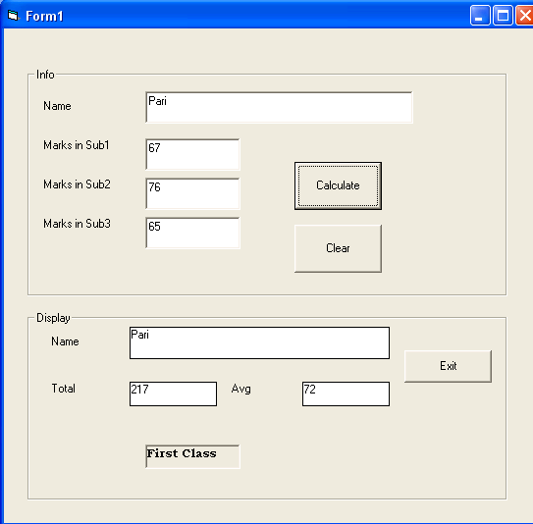

Command button

Frame box

Command button

label

label

**Experiment No. 23**

**Experiment Name: Write a program in Visual basic that calculates area of circle and rectangle.**

Private Sub cmd_circle_Click() Dim Radius As Integer

Radius = InputBox("Type In The Radius", "Radius") Dim Area

Area = 3.14 * (Radius * Radius)

MsgBox Area, vbDefaultButton1, "Answer" End Sub

Private Sub cmd_rect_Click() Dim Length As Double

Length = InputBox("Type In The Length", "Length") Dim Breadth As Double

Breadth = InputBox("Type In The Breadth", "Breadth") Dim Area

Area = (Length * Breadth)

MsgBox Area, vbDefaultButton1, "Answer" End Sub

